**Set Up Selenium Grid**

Download Selenium standalone Server jar file from [https://www.seleniumhq.org/download/ l](https://www.seleniumhq.org/download/)ink

**java -jar selenium-server-4.10.0.jar hub**

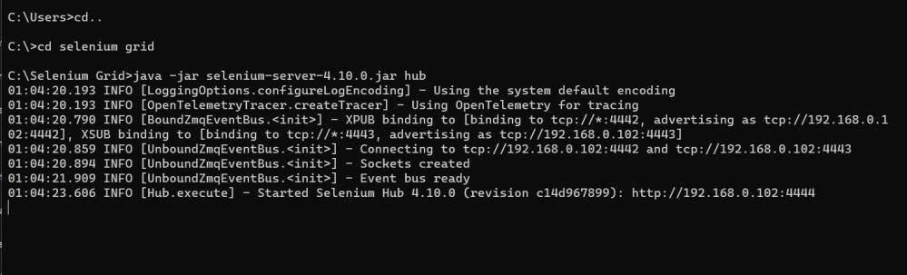

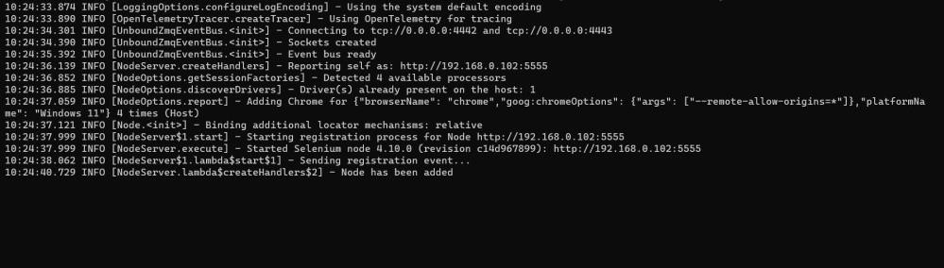

# Open chrome browser - Enter URL as http://localhost:4444

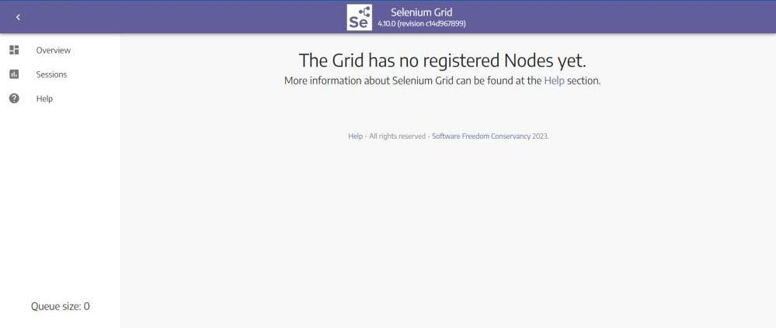

**java - Dwebdriver.chrome.driver=C:\Users\Saiyogesh\Downloads\chromedriv er jar selenium-server-4.10.0.jar node**

# Open chrome browser - Enter URL as http://localhost:4444

